Executive Summary

AP-05 Executive Summary - 24 CFR 91.200(c), 91.220(b)
1. Introduction
The City of Harrisonburg has prepared a FY 2021 Annual Action Plan, as required under 24 CFR 91.220, in order to strategically implement the federal Community Development Block Grant program to fund housing, community development, and economic development activities within the city. The city has developed a Five Year Consolidated Plan (CP) for HUD FY 2017 - FY 2021 to encompass the needs of the city related to both housing and non-housing activities using the Community Development Block Grant (CDBG) Program.
The FY 2021 Annual Action Plan will serve the following functions for the city:
- An application for federal funds under HUD’s formula grant programs, and
- An action plan that provides a basis for assessing performance.
The national goals for the housing and community development programs covered by the Five Year CP and Annual Action Plan are:
- To provide decent housing,
- To establish and maintain a suitable living environment, and
- To expand economic opportunities for every American, particularly for low- and moderate-income persons.
It is these goals against which the CP and the City’s performance under the CP will be evaluated by HUD. The FY 2021 Action Plan furthers the achievement of these goals through the implementation of a variety of housing and community development activities.
The City anticipates that 100% of its FY 2021 CDBG funds will be expended for projects that benefit low- to moderate-income persons in the City.
2. Summarize the objectives and outcomes identified in the Plan
This could be a restatement of items or a table listed elsewhere in the plan or a reference to another location. It may also contain any essential items from the housing and homeless needs assessment, the housing market analysis or the strategic plan.
The city’s FY 2021 Annual Action Plan goals are based on the Five Year Strategy developed for HUD FY 2017-FY 2021. In addition, these goals represent activities that are expected to occur in FY 2017 – FY 2021. The city will monitor and modify strategy performance and set annual goals in future years accordingly.
The city’s FY 2021 funding strategy for its CDBG activities consists of its CDBG entitlement allocation of $532,571. The following chart lists the city’s FY 2021 CDBG activities.
Administration | $106,514
HRHA Harrison Heights | $140,000
VPAS Meals on Wheels | $20,000
The Arc | $17,473
Suitcase Clinic | $31,000
CASA | $11,412
Ralph Sampson Park ADA Sidewalks | $63,000
Commerce and Washington Sidewalks | $143,172
Table 1 - 2021 PROPOSED FUNDING
3. Evaluation of past performance
This is an evaluation of past performance that helped lead the grantee to choose its goals or projects.
The city affirmatively furthered fair housing by providing the Harrisonburg Redevelopment & Housing Authority (HRHA) with $140,000 to assist in the rehabilitation of 40 public housing units in the Harrison Heights complex. Over recent years, the city has broadened its partnership with the HRHA to work together to research and produce a shared Assessment of Fair Housing (AFH). This was an extensive undertaking that allowed city staff to see many areas of improvement that were needed within the city in the area of fair housing. The city has seen an increase in the amount of diversity on the City Council and other planning boards in the city. CDBG staff continues to modify and disseminate educational materials regarding fair housing choice. Posters were displayed in the city. The city's Community Development department has limited the permits granted to Airbnb businesses in an attempt to maintain a greater amount of affordable housing stock in the city. CDBG staff continued to research the feasibility of developing, in tandem with HRHA staff and City Community Planning and Development, proposals for consideration by Council that would improve and preserve the city’s existing affordable housing stock. These proposals could incentivize affordable housing development by waiving permitting and other fees. The city is currently considering creating a new zoning district with smaller lots for single family homes and duplexes. If passed for approval, this district would enable developers to create more affordable housing opportunities in the city. Final consideration of any proposal by staff would be made by the City Planning Commission and ultimately City Council. In 2020, the city brought in a consultant to develop a comprehensive city-wide housing study to further the understanding of Harrisonburg’s affordable housing needs. The city has been in communication with the Piedmont Housing Authority to schedule Fair Housing Discrimination testing for both race and disability in Harrisonburg’s rental housing. Unfortunately, the city has been able to locate any organization that has the resources available for this type of testing. The city successfully implemented all past Action Plans and therefore has made plans to fund many similar projects to those in the past.
In FY 2020-2021, all CDBG funds expended for activities met one of the three national objectives as defined under the CDBG regulations, and 100% of the CDBG funds expended benefited low- to moderate-income persons.
4. Summary of Citizen Participation Process and consultation process
Summary from citizen participation section of plan.
The City of Harrisonburg conducted two public meetings during the Action Plan process to solicit additional public input. A public meeting was held on January 26, 2021 at the Harrisonburg City Council Chambers to explain the CDBG program and Action Plan process, and to get input on the types of projects to be funded. This meeting was publicized in the following ways: Advertised in the Daily News Record, listed on the City’s website (www.harrisonburgva.gov), Public notices were posted in the Municipal Building and Public Library. The Public Notice can be found at the end of this section. The information solicited from the public meeting was incorporated into the Action Plan planning process.
A second public meeting was held on March 23, 2021. At this meeting, the draft HUD FY 2021 Annual Plan was presented to City Council. This meeting was publicized in the following ways: Advertised in the Daily News Record, Listed on the City’s website (www.harrisonburgva.gov), Public notices were posted in the Municipal Building and Public Library. The public notice from the March 23, 2021 public meeting can be found at the end of this section. A draft of the Action Plan was made available for public review and comment for 30 days beginning on March 23, 2021. The public comment period was closed on April 26, 2021, and at the May 11, 2021 council meeting the council unanimously approved the City’s 2021 Action Plan.
Public notices of the draft Action Plan, as well as the public meeting, were published in the Daily News Record on March 15, 2021.
In addition to publishing the notices advertising the public meetings and availability of the draft Action Plan for public review, the City also communicated information to key stakeholders and other interested parties. On December 22, 2021, an email was sent to 117 individuals and organizations in the Harrisonburg area, informing them of the CDBG application process, as well as the dates for public hearings. These organizations and individuals include all parties that have expressed interest in CDBG in the past, and include organizations that target populations of minorities, non-English speaking persons, individuals with disabilities, the Continuum of Care, housing development contacts, and resident representatives of organizations in targeted areas. Throughout the months of January through March 2021, CDBG staff met with and communicated with many agencies and organizations interested in applying for the CDBG and CDBG funding. These meetings helped organizations to understand the application process and eligibility requirements of the CDBG. CDBG staff also held a training session on January 26th for those interested in applying for the grant. CDBG staff also heard input from these organizations regarding needs within the City.
The City made the draft FY 2021 Annual Action Plan available for public review on the City’s website beginning March 23, 2021. The City anticipates submitting the City Council-approved FY 2021 Annual Action Plan to HUD shortly after May 11, 2011.
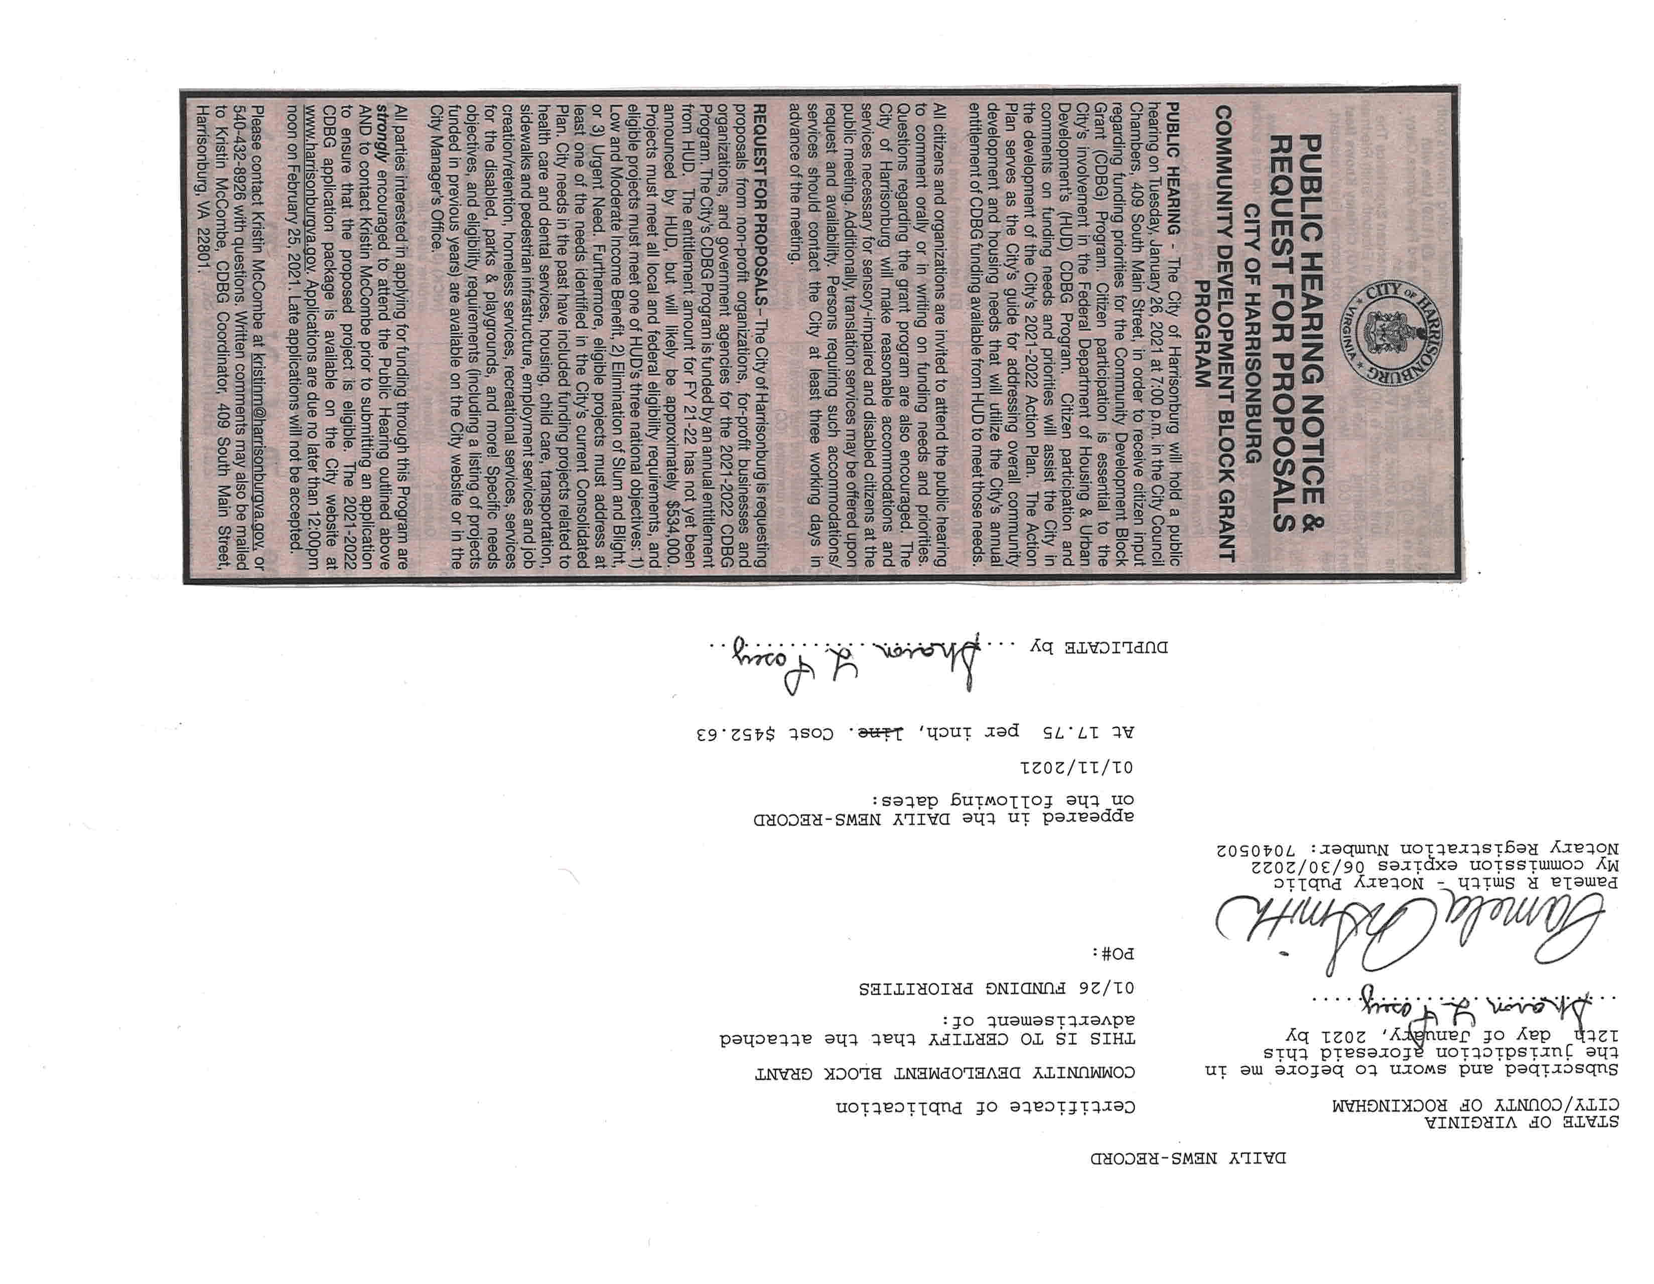
Public Notice 1
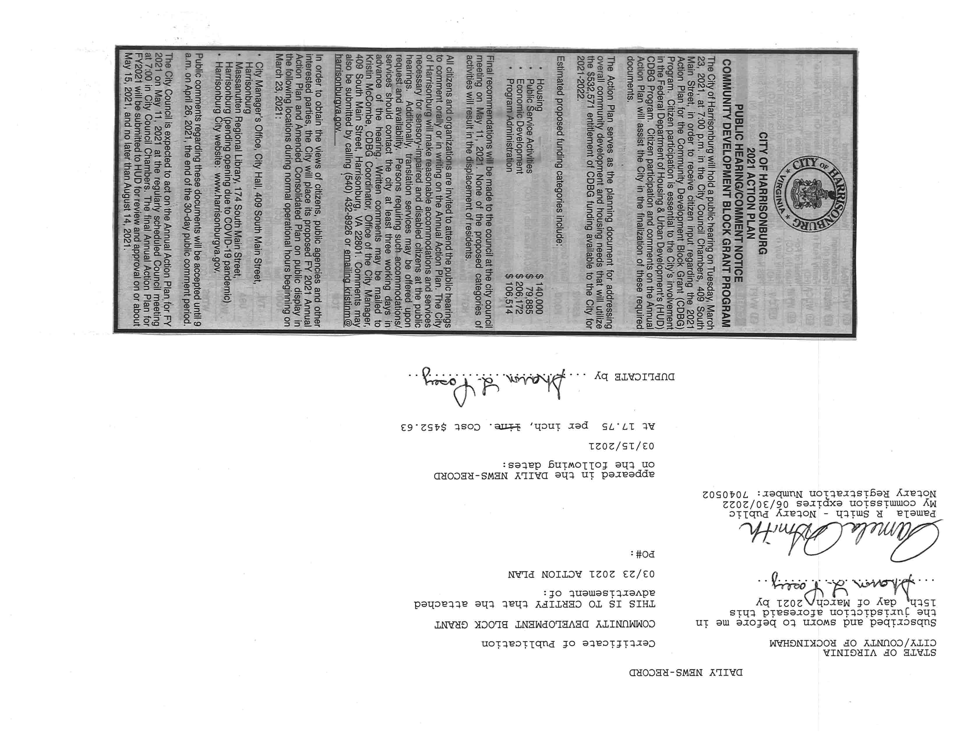
Public Notice 2
5. Summary of public comments
This could be a brief narrative summary or reference an attached document from the Citizen Participation section of the Con Plan.
Comments from the January Public Hearing and Public Comment Period:
Pamayotis “Poti” Giannakaouros, stated he has repeatedly stated the requirements needed for the city to qualify for CDBG funds, and that requirement includes our city be making progress against segregation. He stated we have routinely failed at this and hopes the new HUD administration will be more proactive into looking at the impact and taking action to help localities come into compliance. He stated that we are more segregated at the neighborhood level than the required annual reports suggest. He stated it was even more apparent due to the morbidity rate due to COVID 19. He stated we need to roll back exclusionary practices in land use, zoning, and ordinances. He stated these are easy to do. He stated that we claim we are fiscally conservative, yet we pay an entire set of staff, the enforcement staff in Planning and Zoning, to impose exclusionary practices. He stated in the midst of our COVID crisis they acted on nearly 100 complaints of petty ordinances. He stated this type of activity alienates a specific participation of our residents. He stated Council should follow the examples put in place by leaders of other localities, and the very simple one would be to rescind the tall grass and weed ordinance. He spoke further on credibility, alienation, and trust and asked Council to do it for the health of our community.
No other comments were recieved.
Comments from the March Public Hearing and Public Comment Period:

6. Summary of comments or views not accepted and the reasons for not accepting them
The City did not receive any comments on the plan that were not accepted.
7. Summary
The city of Harrisonburg looks forward to benefiting LMI individuals in the city during the 2021 grant period.

PR-05 Lead & Responsible Agencies – 91.200(b)
1. Agency/entity responsible for preparing/administering the Consolidated Plan
Describe the agency/entity responsible for preparing the Consolidated Plan and those responsible for administration of each grant program and funding source.
Agency Role | Name | Department/Agency

CDBG Administrator |  | City Manager's Office
Table 1 – Responsible Agencies

Narrative (optional)
The lead agency for the Consolidated Plan is the City of Harrisonburg City Manager's Office which administers the CDBG program. Several city departments are active stakeholders in community development projects and improvements, including Community Development, Economic Development, Public Transportation, Parks and Recreation, Public Utilities, and Public Works. In addition, Harrisonburg Redevelopment and Housing Authority (HRHA) will play a large role in providing and managing housing programs covered by this plan.
Consolidated Plan Public Contact Information
Kristin McCombe, CDBG Program Coordinator
City Manager's Office
409 South Main St Harrisonburg, VA 22801

AP-10 Consultation – 91.100, 91.200(b), 91.215(l)
1. Introduction
In 2016-2017 the City of Harrisonburg went through extensive consultation to prepare the Five Year Consolidated Plan. During that time, the city developed a coordinated outreach effort to maximize input from a large cross-section of stakeholders and to continue linking the AFH with the Consolidated Plan and subsequent Action Plans. Individuals who participated during the AFH planning process were afforded the opportunity to reflect and provide feedback on the final goals, milestones, and metrics included in the Consolidated Plan. Outreach initiatives included public meetings, published meeting notices, one-on-one and group interviews, group workshops, and two web-based surveys in both English and Spanish.
Many housing, social service agencies, and other organizations serving the Harrisonburg region were consulted during the development of this Consolidated Plan. They provided information and context that was invaluable to the planning process. Just like for all other CDBG-related activities, the City also strongly encouraged all known stakeholders to participate.
In addition to this, input was solicited both at the Public Hearing on 01/26/2021 and at the Application Training Session on 1/14/2021. This session was attended by many interested organizations in the city. A sample of the agencies and individuals from whom the City regularly solicits feedback is in the Citizen Participation Appendix.
Provide a concise summary of the jurisdiction’s activities to enhance coordination between public and assisted housing providers and private and governmental health, mental health and service agencies (91.215(l))
The city encouraged a high level of public communication and agency consultation when developing the Consolidated Plan to demonstrate its commitment to identifying priority needs and engaging the participation of citizens, public agencies, and nonprofit organizations in a positive and collaborative manner. A list of stakeholders and affordable housing providers was developed for the AFH process and included public agencies and private nonprofit organizations whose missions included the provision of affordable housing and human services to LMI households and persons. These stakeholders were invited to participate in group interviews held to develop the Con Plan.
The community participation process undertaken for the AHF was a collaborative effort between the City of Harrisonburg and Harrisonburg Redevelopment and Housing Authority (HRHA). The city and HRHA partnered with the Virginia Fair Housing Office (VFHO) to provide fair housing training to the community. The VFHO hosted a workshop during the AFH 45-day public comment period to help residents learn about their rights and responsibilities under the Virginia Fair Housing Law and to help the city and HRHA better understand some of the issues residents have personally experienced while searching for, renting, or purchasing housing. Representatives from Blue Ridge Legal Services, Strength in Peers, Mercy House, First Step, Harrisonburg Parks and Recreation, the City Manager's Office, and HRHA were in attendance. Other Fair Housing trainings funded by CDBG were held in January 2018 and April 2019 to continue in these efforts. These trainings were each attended by over 50 individuals from local government and organizations. Additionally, the city conducts a fair housing training annually for all employees, board member, and elected officials that engage with the public on housing matters.
Describe coordination with the Continuum of Care and efforts to address the needs of homeless persons (particularly chronically homeless individuals and families, families with children, veterans, and unaccompanied youth) and persons at risk of homelessness.
The city participates in the Western Virginia Continuum of Care (CoC). Members of the CoC were consulted during the development of the AFH and the Con Plan to understand how to best address the needs of homeless persons and persons at risk of homelessness. Through its cooperation with the CoC, the City will seek to identify ways to enhance coordination among the assisted housing providers and governmental health, mental health, and service agencies.
The city continues to coordinate its housing efforts with HRHA, which is a key member of the CoC. Additionally, CDBG staff remains in contact with staff from organizations in the community who serve this population, such as Open Doors, the Salvation Army, Mercy House, and the Suitcase Clinic.
Describe consultation with the Continuum(s) of Care that serves the jurisdiction's area in determining how to allocate ESG funds, develop performance standards for and evaluate outcomes of projects and activities assisted by ESG funds, and develop funding, policies and procedures for the operation and administration of HMIS
Harrisonburg and HRHA staff will continue to work with the CoC board to undertake the establishment of performance measurements for homeless programs and close coordination with the city's Consolidated Plans. Members of the CoC provided valuable input during public outreach, plan drafting, and project selection process of the 2017-2021 Con Plan.Â
The city's Citizen Participation Plan allows for citizens, community agencies, and the local CoC the opportunity to provide input on the use of all funding. Notifications of the public hearings are published in Harrisonburg's newspaper of largest distribution, the Daily News-Record. Notices are also placed on the city's webpage and in the City Hall. Furthermore, information is made available to current and previous subrecipients.
The city does not receive ESG funds.
2. Describe Agencies, groups, organizations and others who participated in the process and describe the jurisdiction’s consultations with housing, social service agencies and other entities

Table 2 – Agencies, groups, organizations who participated
1 | Agency/Group/Organization | The Arc of Harrisonburg-Rockingham
 | Agency/Group/Organization Type | Services-Persons with Disabilities
 | What section of the Plan was addressed by Consultation? | Non-Homeless Special Needs
 | Briefly describe how the Agency/Group/Organization was consulted. What are the anticipated outcomes of the consultation or areas for improved coordination? | This organization was consulted through a training meeting and brought community needs to the attention of city staff.
2 | Agency/Group/Organization | Open Doors
 | Agency/Group/Organization Type | Services-homeless
 | What section of the Plan was addressed by Consultation? | Homeless Needs - Chronically homeless
 | Briefly describe how the Agency/Group/Organization was consulted. What are the anticipated outcomes of the consultation or areas for improved coordination? | This organization was consulted through a training meeting and brought community needs to the attention of city staff.
3 | Agency/Group/Organization | VPAS
 | Agency/Group/Organization Type | Services-Elderly Persons
 | What section of the Plan was addressed by Consultation? | Non-Homeless Special Needs
 | Briefly describe how the Agency/Group/Organization was consulted. What are the anticipated outcomes of the consultation or areas for improved coordination? | This organization was consulted through a training meeting and brought community needs to the attention of city staff.
4 | Agency/Group/Organization | JMU IIHHS Suitcase Clinic
 | Agency/Group/Organization Type | Services-homeless  Services-Health
 | What section of the Plan was addressed by Consultation? | Homeless Needs - Chronically homeless  Homeless Needs - Families with children
 | Briefly describe how the Agency/Group/Organization was consulted. What are the anticipated outcomes of the consultation or areas for improved coordination? | This organization was consulted through a training meeting and brought community needs to the attention of city staff.
5 | Agency/Group/Organization | SALVATION ARMY
 | Agency/Group/Organization Type | Services-homeless
 | What section of the Plan was addressed by Consultation? | Homeless Needs - Chronically homeless  Homeless Needs - Families with children
 | Briefly describe how the Agency/Group/Organization was consulted. What are the anticipated outcomes of the consultation or areas for improved coordination? | This organization was consulted through a training meeting and brought community needs to the attention of city staff.
6 | Agency/Group/Organization | HRHA
 | Agency/Group/Organization Type | Housing  PHA  Services - Housing
 | What section of the Plan was addressed by Consultation? | Public Housing Needs
 | Briefly describe how the Agency/Group/Organization was consulted. What are the anticipated outcomes of the consultation or areas for improved coordination? | This organization was consulted through a training meeting and brought community needs to the attention of city staff.
7 | Agency/Group/Organization | Our Community Place
 | Agency/Group/Organization Type | Services - Housing  Services-homeless
 | What section of the Plan was addressed by Consultation? | Homeless Needs - Chronically homeless  Homeless Needs - Families with children
 | Briefly describe how the Agency/Group/Organization was consulted. What are the anticipated outcomes of the consultation or areas for improved coordination?
8 | Agency/Group/Organization | Community Services Board
 | Agency/Group/Organization Type | Services-Children
 | What section of the Plan was addressed by Consultation? | Non-Homeless Special Needs
 | Briefly describe how the Agency/Group/Organization was consulted. What are the anticipated outcomes of the consultation or areas for improved coordination? | This organization was consulted through meetings and brought community needs to the attention of city staff.
9 | Agency/Group/Organization | PLEASANT VIEW
 | Agency/Group/Organization Type | Services-Persons with Disabilities
 | What section of the Plan was addressed by Consultation? | Non-Homeless Special Needs
 | Briefly describe how the Agency/Group/Organization was consulted. What are the anticipated outcomes of the consultation or areas for improved coordination? | This organization was consulted through a training meeting and brought community needs to the attention of city staff.
10 | Agency/Group/Organization | Northeast Neighborhood Association
 | Agency/Group/Organization Type | Civic Leaders  Neighborhood Organization
 | What section of the Plan was addressed by Consultation? | Neighborhood Improvement and Education
 | Briefly describe how the Agency/Group/Organization was consulted. What are the anticipated outcomes of the consultation or areas for improved coordination? | This organization was consulted through a training meeting and brought community needs to the attention of city staff.
11 | Agency/Group/Organization | NEWBRIDGES
 | Agency/Group/Organization Type | Services-Education
 | What section of the Plan was addressed by Consultation? | Non-Homeless Special Needs
 | Briefly describe how the Agency/Group/Organization was consulted. What are the anticipated outcomes of the consultation or areas for improved coordination? | This organization was consulted through a training meeting and brought community needs to the attention of city staff.
12 | Agency/Group/Organization | Blue Ridge CASA
 | Agency/Group/Organization Type | Services-Children  Services-Victims of Domestic Violence  Services - Victims
 | What section of the Plan was addressed by Consultation? | Non-Homeless Special Needs
 | Briefly describe how the Agency/Group/Organization was consulted. What are the anticipated outcomes of the consultation or areas for improved coordination? | This organization was consulted through a training meeting and brought community needs to the attention of city staff.
13 | Agency/Group/Organization | WAY TO GO
 | Agency/Group/Organization Type | Services-Employment
 | What section of the Plan was addressed by Consultation? | Non-Homeless Special Needs
 | Briefly describe how the Agency/Group/Organization was consulted. What are the anticipated outcomes of the consultation or areas for improved coordination? | This organization was consulted through a training meeting and brought community needs to the attention of city staff.
14 | Agency/Group/Organization | Friendship Industries
 | Agency/Group/Organization Type | Services-Persons with Disabilities
 | What section of the Plan was addressed by Consultation? | Non-Homeless Special Needs
 | Briefly describe how the Agency/Group/Organization was consulted. What are the anticipated outcomes of the consultation or areas for improved coordination? | This organization was consulted through a training meeting and brought community needs to the attention of city staff.

Identify any Agency Types not consulted and provide rationale for not consulting
All entities were considered for consultation.

Other local/regional/state/federal planning efforts considered when preparing the Plan
Name of Plan | Lead Organization | How do the goals of your Strategic Plan overlap with the goals of each plan?
Continuum of Care | HRHA | The efforts to reach homeless individuals in Harrisonburg correlate with this plan.
Table 3 – Other local / regional / federal planning efforts

Narrative (optional)

AP-12 Participation – 91.105, 91.200(c)
1. Summary of citizen participation process/Efforts made to broaden citizen participation
Summarize citizen participation process and how it impacted goal-setting

Public hearings were held on January 26, 2021, and March 23, 2021 to solicit input from the public. Both hearings were advertised in the Daily News-Record and on the City’s website.
On January 14, 2021, CDBG staff held a training session for prospective CDBG applicants. During that meeting, participants were given an opportunity to learn more about the CDBG program, and CDBG staff heard community input regarding the needs of organizations in attendance. Many meetings and phone calls followed this training. Staff was able to gain insight into the work these organizations are doing, and the needs they see in the city.

Citizen Participation Outreach
Sort Order | Mode of Outreach | Target of Outreach | Summary of  response/attendance | Summary of  comments received | Summary of comments not accepted and reasons | URL (If applicable)
1 | Public Meeting | Non-targeted/broad community | The meetings occurred during a period of social distancing related to the COVID-19 pandemic. The meetings did not allow for in person citizen attendance, but were broadcast live on public access TV, and through streaming internet. Live comments were accommodated. | Comments were received and detailed earlier in this plan.
Table 4 – Citizen Participation Outreach

Expected Resources

AP-15 Expected Resources – 91.220(c)(1,2)
Introduction
Harrisonburg receives only CDBG funds for housing construction, rehabilitation initiatives, public services, economic development, and other eligible activities. These funding sources are expected to be available over the next five years.
Anticipated Resources
Program | Source of Funds | Uses of Funds | Expected Amount Available Year 1 |  |  |  | Expected Amount Available Remainder of ConPlan  $ | Narrative Description
 |  |  | Annual Allocation: $ | Program Income: $ | Prior Year Resources: $ | Total:  $
CDBG | public - federal | Acquisition  Admin and Planning  Economic Development  Housing  Public Improvements  Public Services | 532,571 | 0 | 0 | 532,571 | 0 | This is the last year of the five year plan.
Table 1 - Expected Resources – Priority Table

Explain how federal funds will leverage those additional resources (private, state and local funds), including a description of how matching requirements will be satisfied
Over the next year, Harrisonburg will attempt to leverage its CDBG allocation with federal and other public resources, as well as private sector funding sources, to address the City's housing and community development needs. The City will continue to partner with other public agencies and non-profit organizations, when feasible, to leverage resources and maximize outcomes in providing the housing and supportive services needs of the community.
One ongoing example of cooperation and mutual resource leveraging is the City’s allocation of its CDBG funds for loan debt service reduction incurred for the rehabilitation of 40 units of affordable housing at Harrison Heights, a Section 8 project-based development managed by Harrisonburg Redevelopment and Housing Authority (HRHA). This allocation has continued annually during the FY2017-2021 planning cycle.
Another very important local public resource is the City of Harrisonburg's General Fund. Each year, the City provides general funds to support organizations that provide housing and/or supportive services to area residents, including LMI households.

If appropriate, describe publically owned land or property located within the jurisdiction that may be used to address the needs identified in the plan
Harrisonburg does not anticipate that any publicly owned land or property will be used to address the needs identified in the Five-Year Consolidated Plan.
Discussion

Annual Goals and Objectives

AP-20 Annual Goals and Objectives
Goals Summary Information
Sort Order | Goal Name | Start Year | End Year | Category | Geographic Area | Needs Addressed | Funding | Goal Outcome Indicator
1 | AFH: Improve access to and quality of housing | 2017 | 2021 | Affordable Housing  Public Housing | Citywide | AFH FACTOR: Affordable Housing | CDBG: $140,000 | Rental units rehabilitated: 40 Household Housing Unit
2 | Provide public services | 2017 | 2021 | Homeless  Non-Homeless Special Needs | Citywide | Public Services  Housing/services for the Homeless | CDBG: $79,885 | Public service activities other than Low/Moderate Income Housing Benefit: 445 Persons Assisted
3 | Improve public facilities and infrastructure | 2017 | 2021 | Non-Housing Community Development |  | Public Facilities and Infrastructure | CDBG: $206,172 | Public Facility or Infrastructure Activities other than Low/Moderate Income Housing Benefit: 6195 Persons Assisted
4 | AFH: Admin, training, investigation & enforcement | 2017 | 2021 | Administration | Citywide | AFH FACTOR: Fair Housing Education and Enforcement  Planning and Administration | CDBG: $106,514 | Other: 1 Other
Table 2 – Goals Summary

Goal Descriptions

1 | Goal Name | AFH: Improve access to and quality of housing
 | Goal Description
2 | Goal Name | Provide public services
 | Goal Description
3 | Goal Name | Improve public facilities and infrastructure
 | Goal Description
4 | Goal Name | AFH: Admin, training, investigation & enforcement
 | Goal Description

Projects

AP-35 Projects – 91.220(d)
Introduction
The following project information for FY 2021 provides a comprehensive overview of CDBG activities.

Projects
# | Project Name
1 | Sidewalks on Commerce Dr. and Washington St.
2 | Ralph Sampson Park ADA Improvements
3 | CASA Child Advocacy Program
4 | VPAS Meals on Wheels
5 | The Arc SpArc Employment Prep and Virtual Day Support Enhancement and Expansion
6 | JMU IIHHS Suitcase Clinic
7 | Administration
8 | HRHA Harrison Heights
Table 3 - Project Information

Describe the reasons for allocation priorities and any obstacles to addressing underserved needs

AP-38 Project Summary
Project Summary Information

1 | Project Name | Sidewalks on Commerce Dr. and Washington St.
 | Target Area
 | Goals Supported
 | Needs Addressed
 | Funding | :
 | Description | Construct sidewalks on the South and West Side of Commerce Drive to fill the gap between N. Main St. and Commerce Village. A sidewalk will also be installed on the north side of E. Washington St. between Commerce Drive and the existing sidewalk at Simms Ave. Curb cuts, and ADA compliance activities will also be achieved in these areas.
 | Target Date
 | Estimate the number and type of families that will benefit from the proposed activities
 | Location Description
 | Planned Activities
2 | Project Name | Ralph Sampson Park ADA Improvements
 | Target Area
 | Goals Supported
 | Needs Addressed
 | Funding | :
 | Description | Construction of ADA sidewalks and ADA improvements at Ralph Sampson Park
 | Target Date
 | Estimate the number and type of families that will benefit from the proposed activities
 | Location Description
 | Planned Activities
3 | Project Name | CASA Child Advocacy Program
 | Target Area
 | Goals Supported
 | Needs Addressed
 | Funding | :
 | Description | Funds will be used to pay for a child advocacy manager position.
 | Target Date
 | Estimate the number and type of families that will benefit from the proposed activities
 | Location Description
 | Planned Activities
4 | Project Name | VPAS Meals on Wheels
 | Target Area
 | Goals Supported
 | Needs Addressed
 | Funding | :
 | Description | Funding will be used to pay for the home delivery of meals to residents over age 62.
 | Target Date
 | Estimate the number and type of families that will benefit from the proposed activities
 | Location Description
 | Planned Activities
5 | Project Name | The Arc SpArc Employment Prep and Virtual Day Support Enhancement and Expansion
 | Target Area
 | Goals Supported
 | Needs Addressed
 | Funding | :
 | Description | Funding will be used for the downpayment on a van, vehicle costs, and technology for the day support program.
 | Target Date
 | Estimate the number and type of families that will benefit from the proposed activities
 | Location Description
 | Planned Activities
6 | Project Name | JMU IIHHS Suitcase Clinic
 | Target Area
 | Goals Supported
 | Needs Addressed
 | Funding | :
 | Description | CDBG will pay for durable and disposable medical goods, dental, prescriptions, mental health services, and other medical expenses for LMI residents.
 | Target Date
 | Estimate the number and type of families that will benefit from the proposed activities
 | Location Description
 | Planned Activities
7 | Project Name | Administration
 | Target Area
 | Goals Supported
 | Needs Addressed
 | Funding | :
 | Description | General CDBG administration and planning costs
 | Target Date
 | Estimate the number and type of families that will benefit from the proposed activities
 | Location Description
 | Planned Activities
8 | Project Name | HRHA Harrison Heights
 | Target Area
 | Goals Supported
 | Needs Addressed
 | Funding | :
 | Description | Continuing debt servicing on the Harrison Heights renovation.
 | Target Date
 | Estimate the number and type of families that will benefit from the proposed activities
 | Location Description
 | Planned Activities

AP-50 Geographic Distribution – 91.220(f)
Description of the geographic areas of the entitlement (including areas of low-income and minority concentration) where assistance will be directed
The City of Harrisonburg is using $186,399 of its FY 2021 CDBG funds for activities and programs that will provide a benefit to the entire City, which includes all areas of concentration of low/moderate income residents and minority populations.
26% of the funds will pay for the debt service incurred by HRHA for housing rehabilitation of subsidized housing in census block group 101.3, which is 69% LMI and has a concentration of Hispanic and Black populations.
12% of the funds will pay for accessibility updates at Ralph Sampson Park, which serves census blocks 101.1, 101.2 and 101.3, which accumulatively are 61% LMI.
27% of the funds will pay for a sidewalk on Commerce Dr. and Washington St., which serves block 101.1 and is 56% LMI.
Geographic Distribution
Target Area | Percentage of Funds
Citywide | 100
Table 4 - Geographic Distribution

Rationale for the priorities for allocating investments geographically
Harrisonburg does not allocate funds by target areas. Rather, the City allocates funds based upon the priorities that have been identified by citizens participating in the public input process and through the regular planning contacts made with elected officials and staff. The City will use CDBG funds throughout the jurisdiction to serve low and moderate-income persons.
Discussion

Affordable Housing

AP-55 Affordable Housing – 91.220(g)
Introduction
The City will use its federal funds to provide affordable housing by continuing its $140,000 allocation of CDBG funds for payment of debt service incurred for the rehabilitation of units at the Harrison Heights project-based development. The 40 units supported through this project are not new units created during this fiscal year, but are included in the following tabulations nonetheless.
The HRHA first time homebuyers closing cost assistance program will also continue to spend down its funding from previous grant year allocations. This is a significant area in which CDBG funds are used to enable people to buy homes who otherwise may not be able.
The special needs population will be served through grants to local service providers. The homeless population will be served through assistance grants to local service providers. The following estimates have been based on the information in SP-45.
One Year Goals for the Number of Households to be Supported
Homeless | 300
Non-Homeless | 175
Special-Needs | 59
Total | 534
Table 6 - One Year Goals for Affordable Housing by Support Requirement

One Year Goals for the Number of Households Supported Through
Rental Assistance | 0
The Production of New Units | 0
Rehab of Existing Units | 40
Acquisition of Existing Units | 0
Total | 40
Table 7 - One Year Goals for Affordable Housing by Support Type

Discussion

AP-60 Public Housing – 91.220(h)
Introduction
Harrisonburg Redevelopment and Housing Authority’s (HRHA) mission is “to promote adequate and affordable housing economic opportunity and a suitable living environment free from discrimination; and to foster redevelopment of blighted areas to ensure the economic, social and housing vitality of our community."
Actions planned during the next year to address the needs to public housing
As of 2009, HRHA has converted its public housing units into project-based Section 8 units. HRHA currently owns and manages a total of 250 residential units including one affordable apartment building for seniors, a new apartment complex for homeless individuals, 129 townhomes for rent, and two small vacant sites.
For FY 2017-2021, the City will continue the commitment of funds made in 2006 for the renovation of Harrison Heights.
Actions to encourage public housing residents to become more involved in management and participate in homeownership
All HRHA tenants who are not elderly or disabled participate in a 5-year family self-sufficiency program designed to transition them out of HRHA managed units and into private sector housing. Those residents that do not graduate receive a Housing Choice Voucher (HCV). Through either outcome, HRHA residents are encouraged to more fully integrate into the community. The HRHA first time homebuyers closing cost assistance program will also continue to spend down its funding from previous grant year allocations. This is a significant area in which CDBG funds are used to enable people to buy homes who otherwise may not be able.
If the PHA is designated as troubled, describe the manner in which financial assistance will be provided or other assistance
HRHA is not designated as troubled.
Discussion

AP-65 Homeless and Other Special Needs Activities – 91.220(i)
Introduction
As a participant in the Western Virginia Continuum of Care (CoC), the City is a partner in addressing homelessness and the priority needs of homeless individuals and families, including homeless subpopulations.
Describe the jurisdictions one-year goals and actions for reducing and ending homelessness including
Reaching out to homeless persons (especially unsheltered persons) and assessing their individual needs
Centralized Housing Intake (CHI) for the City of Harrisonburg, City of Winchester, and counties of Rockingham, Clarke, Frederick, Shenandoah, Warren, and Page offers a central point of entry for households experiencing homelessness or at-risk of homelessness. During an initial phone call, a housing counselor asks questions that will help determine eligibility for services with local agencies.
Each January, the CoC conducts a Point-in-Time (PIT) count of the City’s sheltered and unsheltered homeless to ascertain the number and characteristics of the homeless population and to assess their needs. Harrisonburg’s continued participation in the PIT study will give the City the ability to collect information to be used in setting priorities, written standards, and performance measures for the area.
Addressing the emergency shelter and transitional housing needs of homeless persons
During FY 2021, the City’s federal CDBG funds will support the following shelter and transitional housing program:
- IIHHS Suitcase Clinic
Helping homeless persons (especially chronically homeless individuals and families, families with children, veterans and their families, and unaccompanied youth) make the transition to permanent housing and independent living, including shortening the period of time that individuals and families experience homelessness, facilitating access for homeless individuals and families to affordable housing units, and preventing individuals and families who were recently homeless from becoming homeless again
The City will maintain coordination and collaboration with local non-profit agencies serving the homeless population. The City will continue will use its entitlement grant funds to assist non-profit organizations that serve homeless individuals and families in Harrisonburg and to support the CoC and assist in coordinating homeless resources throughout the City.
During FY 2021, the City’s federal funds support the following affordable housing program:
- HRHA - Harrison Heights Renovation
Helping low-income individuals and families avoid becoming homeless, especially extremely low-income individuals and families and those who are: being discharged from publicly funded institutions and systems of care (such as health care facilities, mental health facilities, foster care and other youth facilities, and corrections programs and institutions); or, receiving assistance from public or private agencies that address housing, health, social services, employment, education, or youth needs.

Discussion
The City recognizes a need for neighborhood-based homelessness prevention programs, such as crisis response and stabilization, street outreach, housing search and placement specialists, and increased employment opportunities that provide temporary rental assistance and other services.
During FY 2021, the City’s federal funds support the following supportive service programs:
- VPAS - Meals on Wheels
- JMU IIHHS - Suitcase Clinic
- The Arc - Day Program
- CASA

AP-75 Barriers to affordable housing – 91.220(j)
Introduction:
The City’s housing market presents significant impediments to the development of an adequate supply of affordable housing for low- to moderate-income people – high competition for entry-level employment opportunities, rising construction and land costs, a rental market driven by student housing, and more. In addition, there are a number of public policy barriers that affordable housing advocates and other stakeholders articulated during the public engagement process, including:
- The City’s current zoning ordinance limits the opportunity for both denser single-family and multi-family units
- The legal and administrative complexities of operating a City service in Rockingham County impedes the extension of transit outside the City
- The lack of “source of income” protection allows some landlords to discriminate against Housing Choice Voucher holders
- Some homeless individuals are unable to meet the documentation requirements for social services. This can trap them in an endless loop of agency referrals
- Stricter development standards (e.g. sidewalks and lighting, pedestrian and biking facilities, parking, etc.) have increased the costs of affordable housing development
- The environmental review process required to use CDBG funds can make modifications to single family homes (such as to increase accessibility) not cost effective
Other barriers identified over the course of the outreach for the development of this Consolidated Plan, include:
- Language barriers, especially for refugees
- Lack of assistance available for elderly and LMI residents for major home repairs (foundation, roof, septic, HVAC, etc.) and emergency home repairs that would allow them stay in their homes
- Lack of knowledge of fair housing laws by local landlords
The joint Assessment of Fair Housing completed by the City and Harrisonburg Redevelopment and Housing Authority identified factors that contribute to fair housing issues in the City. The following factors identified in the AFH related specifically to housing affordability and public policies:
- Lack of private investments in specific neighborhoods: For the most part, new private, multi-family development in the City focuses on housing for JMU students. This means that some neighborhoods, particularly those close to JMU, and other amenities sought by students, experience a lot of private investment while others do not.
- The availability, type, frequency, and reliability of public transportation: According to local stakeholders, Harrisonburg’s transit system does not provide access to employment centers or certain critical community amenities such as the central post office in the City’s southern area or the poultry processing facilities in the County. The Harrisonburg Department of Public Transportation’s decision-making ability regarding hours and coverage are limited and tied heavily to the needs of the University, which are frequently mismatched with those of the protected classes in the community.
- Community opposition: HRHA faced vocal community opposition during the planning phase of a new project-based development. This opposition caused HRHA to find an alternate location for the project, which is now called Commerce Village and serves homeless people with mental and physical disabilities. The fact that strong community opposition, although uncommon to this degree in Harrisonburg, can derail an affordable housing project makes addressing this factor moderately urgent.
Actions it planned to remove or ameliorate the negative effects of public policies that serve as barriers to affordable housing such as land use controls, tax policies affecting land, zoning ordinances, building codes, fees and charges, growth limitations, and policies affecting the return on residential investment
The following actions identified in the AFH are intended to reduce the barriers to affordable housing related specifically to public policies:
- Continue to maintain a list of local publicly supported developments with expiring subsidies to identify partners and potential sources of funding for preservation.
- Work with City planning staff to institute an evaluation of the impact on fair housing choice for every residential development proposal. Restructure existing incentives to encourage proposals that increase the supply of affordable housing in high opportunity areas and/or outside of “concentration areas.”
- Within the next five-year planning cycle, create a framework for providing down payment assistance through CDBG and/or HRHA for qualified first time homebuyers.
- Within one year, conduct the four-factor analysis to determine the extent to which document translation is needed. Prepare a Language Access Plan if it is determined to be necessary.
- Annually train City and HRHA staff to refer callers about fair housing to the designated staff person. In addition, train all staff that interact with the public in techniques to communicate with those with language and/or cultural barriers.
- Hold an annual fair housing training for elected officials, appointed boards, and department staff.
Discussion:
During 2020 the city engaged a consultant to produce a housing study for the city. This study is currently being analyzed by city staff to determine the best steps forward for providing more affordable housing options for Harrisonburg residents.

AP-85 Other Actions – 91.220(k)
Introduction:
The following information illustrates other actions that Harrisonburg will take to address its priority needs.
Actions planned to address obstacles to meeting underserved needs
The primary impediment to the City’s ability to meet underserved needs is the limited amount of funding to address identified priorities. The City will continue to seek public and private resources to leverage its entitlement funds in assisting with implementation of policies and programs
Actions planned to foster and maintain affordable housing
The City will continue to support its goals of maintaining and expanding affordable housing. In FY 2021 the City will continue its $140,000 allocation of CDBG funds for payment of debt service incurred for the rehabilitation of units at the Harrison Heights project-based Section 8 development. Additionally, the city will continue to work with the HRHA to use its 2018 and 2020 allocation for Down Payment Assistance, totaling $50,000.
Actions planned to reduce lead-based paint hazards
The City will work with other parties to achieve cost effective methods for controlling these hazards through the following:
- As part of its code enforcement efforts, Harrisonburg's building code department will continue to educate City residents about lead paint hazards.
- Properties will be made lead safe during renovation of older residential units.
- Harrisonburg will continue to demolish pre-1978 nuisance housing, which often contains lead-based paint.
- The City will continue to monitor Virginia Department of Health reports regarding Harrisonburg children with elevated blood lead levels.
- The City may apply for a grant to combat lead-based paint hazards via public education, building code department staff training, and residential rehabilitation that controls or eliminates lead-based paint hazards.
Actions planned to reduce the number of poverty-level families
The City will collaborate with human service, social service, and economic development agencies and organizations to facilitate their efforts and maximize their resources to provide quality services to low-income residents to help them improve their incomes.
Actions planned to develop institutional structure
Although the City feels that the existing institutional structure is sufficient for carrying out activities to address identified community development needs, the City Manager's Office plans to continue to strengthen its working relationships with local social service agencies. Public and non-profit agencies that are critical to the institutional structure must work cooperatively, and agency staff have the ability and expertise to deliver services efficiently and effectively, often with years of expertise in their respective fields.
Actions planned to enhance coordination between public and private housing and social service agencies
The City plans to improve coordination among its partners to promote a broadly shared understanding of community needs, collaborative and complementary approaches to addressing needs, and responsiveness to changes in conditions.
The City will collaborate with numerous governmental entities to carry out the goals and objectives of Harrisonburg housing, homeless services, and community development activities. Implementation partners will include the Commonwealth of Virginia; regional bodies such as the Central Shenandoah Planning District Commission; the Harrisonburg Rockingham Metropolitan Planning Organization; Rockingham County; the Western Virginia Continuum of Care (CoC); Harrisonburg Redevelopment and Housing Authority; and various City departments. Cooperation and coordination among these entities will be achieved through both fixed meeting schedules and as-needed consultation and communication.
The City anticipates continuing its coordination of human service funding with other social service agencies and charitable organizations to better target the limited amount of human service dollars available in the community. The City will also continue to coordinate its housing efforts with the Harrisonburg Redevelopment and Housing Authority (HRHA).
Discussion:

Program Specific Requirements
AP-90 Program Specific Requirements – 91.220(l)(1,2,4)
Introduction:

Community Development Block Grant Program (CDBG)
Reference 24 CFR 91.220(l)(1)
Projects planned with all CDBG funds expected to be available during the year are identified in the Projects Table. The following identifies program income that is available for use that is included in projects to be carried out.

1. The total amount of program income that will have been received before the start of the next program year and that has not yet been reprogrammed | 0
2. The amount of proceeds from section 108 loan guarantees that will be used during the year to address the priority needs and specific objectives identified in the grantee's strategic plan. | 0
3. The amount of surplus funds from urban renewal settlements | 0
4. The amount of any grant funds returned to the line of credit for which the planned use has not been included in a prior statement or plan | 0
5. The amount of income from float-funded activities | 0
Total Program Income: | 0

Other CDBG Requirements
1. The amount of urgent need activities | 0

2. The estimated percentage of CDBG funds that will be used for activities that benefit persons of low and moderate income.Overall Benefit - A consecutive period of one, two or three years may be used to determine that a minimum overall benefit of 70% of CDBG funds is used to benefit persons of low and moderate income. Specify the years covered that include this Annual Action Plan. | 100.00%

