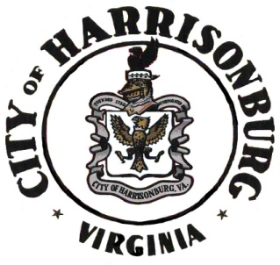

Notice of Public Hearing & Comment Period

Community Development Block Grant Program (CDBG)

Consolidated Annual Performance Evaluation Report (CAPER)

The City of Harrisonburg is seeking public comments for the required CAPER - a document required by the U.S. Department of Housing & Urban Development (HUD) for the evaluation and review of CDBG programs in program year 2024.

Comments may be submitted during the CDBG CAPER Public Hearing portion of the regular City Council meeting on September 9, 2025, at 7:00 P.M. in the City Council Chambers, Harrisonburg Municipal Building, located at 409 S. Main St., Harrisonburg, VA. All comments must be received no later than September 25, 2025 at 9:00 A.M. Comments may be submitted to Kristin McCombe, Community Development Block Grant Program Manager, at 409 South Main Street, Harrisonburg, Virginia 22801, or kristinm@harrisonburgva.gov, or (540) 432-8926.

Copies of the draft CAPER will be available for review in the City Manager’s Office, 409 South Main Street, Harrisonburg, Virginia 22801 and at www.harrisonburgva.gov on the CDBG homepage. A summary of the CAPER is as follows:

In the 2024 year, the city was awarded $491,620 in CDBG entitlement funds, with additional previously unspent funds added in to bring the total to $627,906.37. The following is a summary report of obligated, expended, and remaining funds as of 6/30/2025:

|  |  |  |  |
| --- | --- | --- | --- |
|  | Obligated | Expended | Remaining |
| Housing and Property Improvements | $139,700 | $0.00 | $139,700 |
| Community & Public Facilities | $316,139.37 | $71,400.00 | $244,739.37 |
| Administration | $98,324.00 | $50,207.17 | $48,116.83 |
| Public Services | $73,743.00 | $59,300.48 | $14,442.52 |
| **TOTAL** | **$627,906.37** | **$180,907.65** | **$446,998.72** |

The City of Harrisonburg will make reasonable accommodations and services necessary for sensory-impaired and disabled citizens at the public hearing. Persons requiring such accommodations/services should contact the city at least 5 working days in advance of the hearing. Additionally, interpretation services may be offered upon request and availability. Persons requiring such accommodations/services should contact the city at least 4 working days in advance of the hearing.

El servicio de interpretación en Español está disponible para las reuniones de la Municipalidad de la Ciudad. Para garantizar que los intérpretes estén disponibles en las reuniones, los interesados deben solicitar los servicios por lo menos cuatro (4) días de calendario antes de la reunión, poniéndose en contacto con la secretaria de la Municipalidad al 540-432-7701 o enviando una solicitud en línea.